Our IVF Team
Successful fertility treatment is all about teamwork. From the first consultation right through to the treatment process and afterwards, an experienced, highly skilled and committed team is here to ensure the best possible advice, treatment and care.
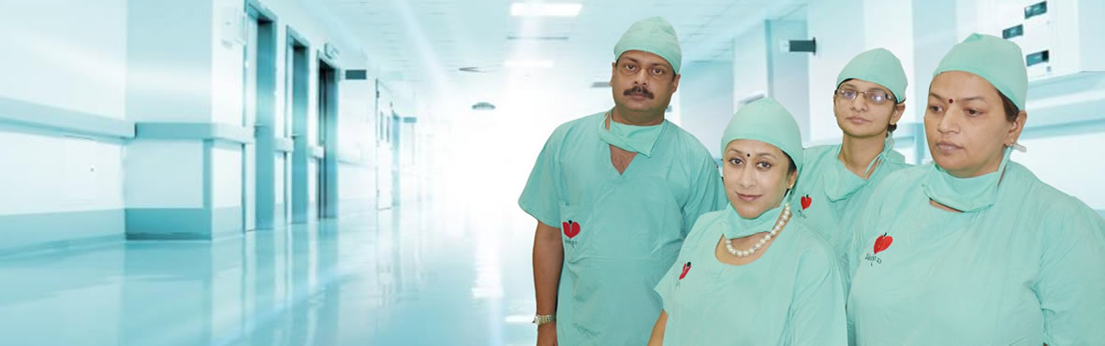
Arpit Test Tube Baby Centre is fully-equipped, with its own surgical and day care facilities. Experienced and highly-qualified staff works in a friendly, relaxed and stress-free atmosphere.
Everything we do is dedicated to one single objective - successful treatment. Everyone at Arpit Test Tube Baby Centre is committed to your success.
Late Dr. A. K. Bansal
M.B.B.S., MS, FAIS, FCGP, FIAGES
Founder
Dr. Vandana Bansal
MS, D.Phil (Gold Medalist), DGO, FCGP
Director
Dr. Arpit Bansal
MBBS, MS, FMAS, FCS
Director
Dr. Hrishikesh Pai
MD, FCPS
Visiting IVF specialist
Dr. Santosh Kumar Singh
MD (Radiologist)
Dr Sachin Manjerekar
Embryologist
Visisting Embryologist
Mr. Saugat Bose
M.Sc. (Biochemistry)
Embryologist
Dr. Anjula Sahai
MBBS, DGO, FCPS
IVF Counselor
Mrs. Pooja Bansal
Embryologist & IVF Counselor
Mrs. Mamta Tiwari
M.Sc. (Medical Micro Biology)
IVF Counselor

